# Sequential Diagrams:

## Event App:

Swipe In: 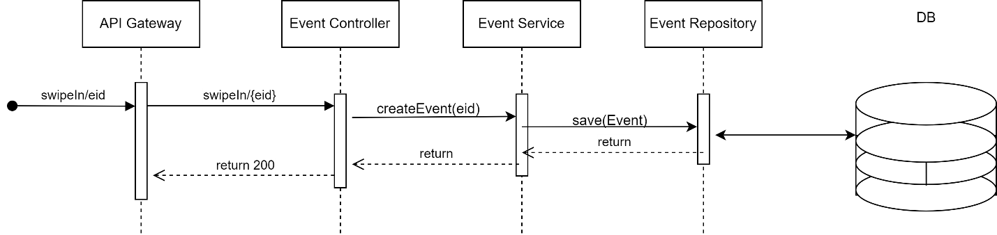

Swipe Out:

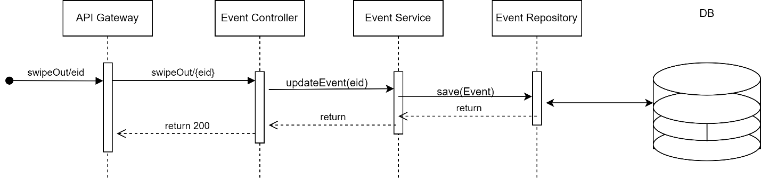

Calculate Attendance: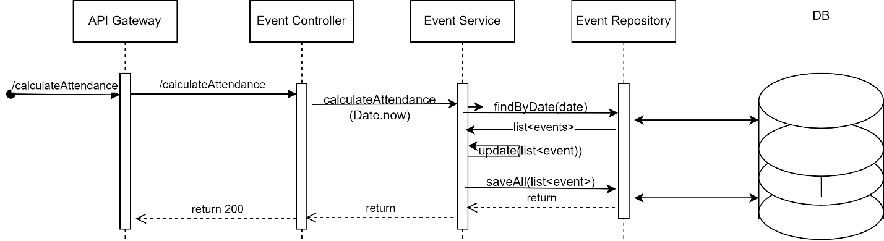

Produce Event: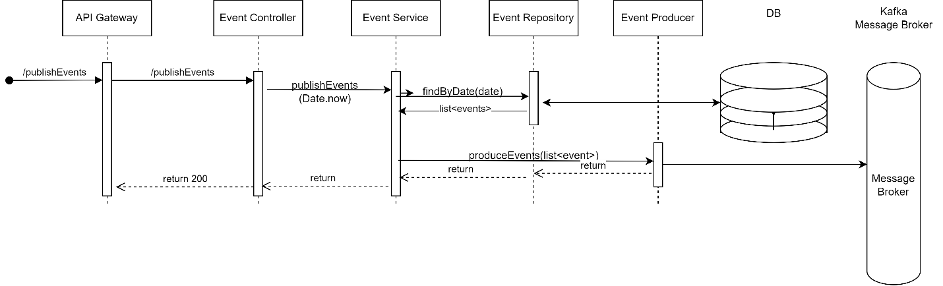

Attendance App:

Create Employee:

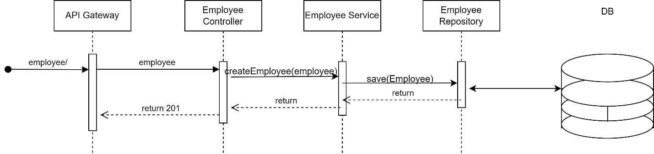

Get Employee:

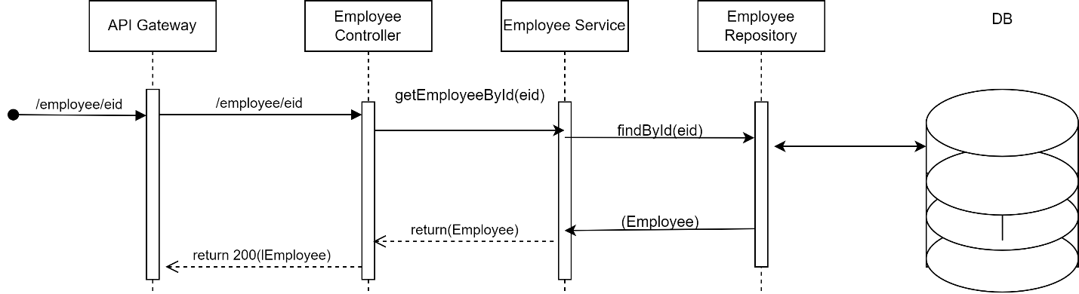

Get All Employee:

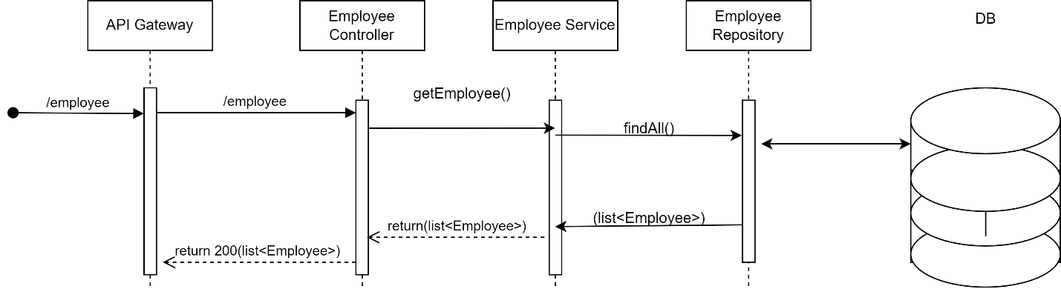

Delete Employee:

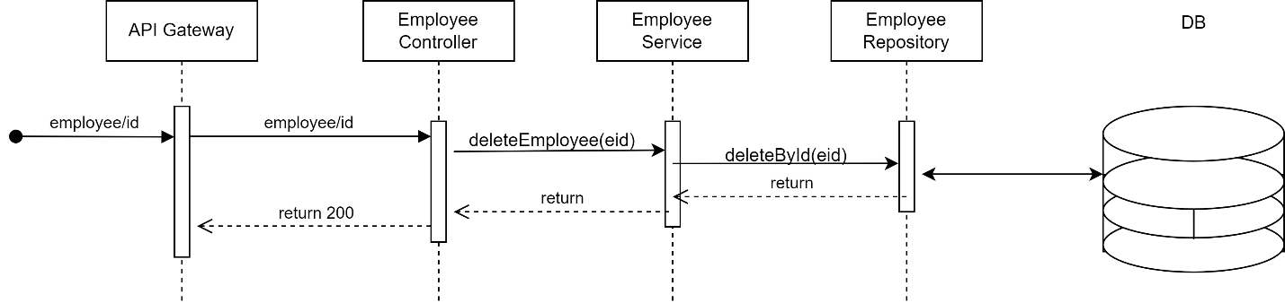

Get Attendance:

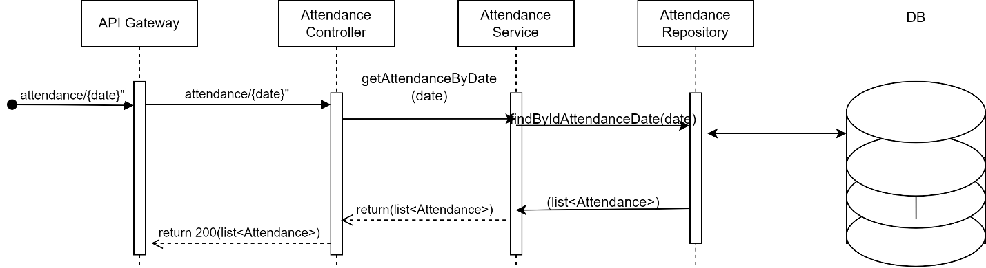

Consume Event:

